

HANNAH
DODARELL

Interior Architect & Designe

PROFILE

CONTACT

PHONE:

+44 (0)7788 737 469

WEBSITE:

https:www.hdodarell.wixsite.com/
hannahdodarell/

EMAIL:

hdodarell@yahoo.co.uk

EDUCATION

The Thomas Hardye School

2005

-

2009

7
GCSEs at C and above.

Weymouth College

2010

-

2013

BTEC Extended Diploma in Art & Design

DMM

University of Portsmouth

2013

-

2016

BA (Hons)
Interior Architecture & Design

2:2

WORK EXPERIENCE

SKILLS
90
%
75
%
100
%
75
%
50
%
Communication
Problem Solving
Technical Hand-Drawing
Adobe CS
AutoCAD
I am a focused, committed and self-motivated individual with a range of skills in design including AutoCAD, Adobe Creative Suite, Microsoft Office, and technical scale hand-drawing, which also includes axonometric drawing. I’m driven and creative, producing my own design work in my spare time. I have adhered to, and produced, work which I have been given strict specifications, and to work with a relatively blank slate, with the necessary creativity, to produce freestyle bespoke designs in a timely manner.
I am looking for full-time employment to gain specific experience shadowing, or working directly, in the design industry. References will verify that I am hard-working, innovative, cheerful and energetic, and I am confident that I will make a noted and effective member of your team.
I am currently seeking to further develop my skills in CAD; using software such as AutoCAD, Photoshop, Illustrator and InDesign. Also, in experimenting with a greater range of artistic materials to bring a new dimension to my visual design work.
WN Interiors | Interior Designer, Temp.
20/02/2017-24/02/2017
A temp. for one week. Gaining invaluable experience and skills in AutoCAD and Photoshop, and working in a close-knit team.
GAME | Seasonal Team Member, Customer Assistant
10/11/2019-04/01/2020
A Seasonal team member for the Christmas period. Assisting customers with all their gaming and technology needs.
DAP: Design Ability Partnership | Interior Architect
25/09/2018 – Present
Working on an as-and-when basis. I create the CAD drawings of the architect’s hand-drawings, and also create the graphics for the company’s web and print outlets.
Crafty Arty World | Graphic Designer, Temp.
17/07/2017-21/07/2017
Working alongside a diverse team, creating graphically aesthetic promotional material for web and print.
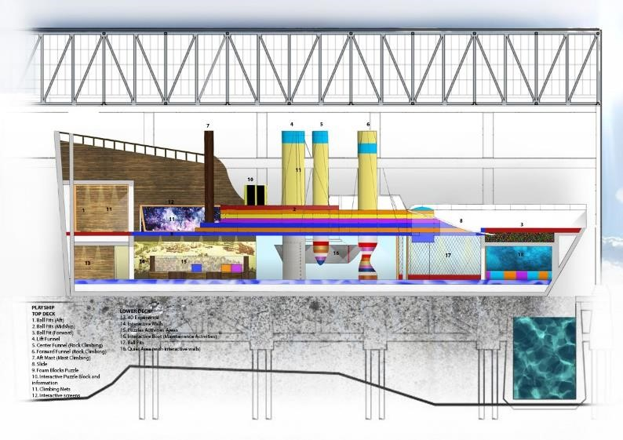
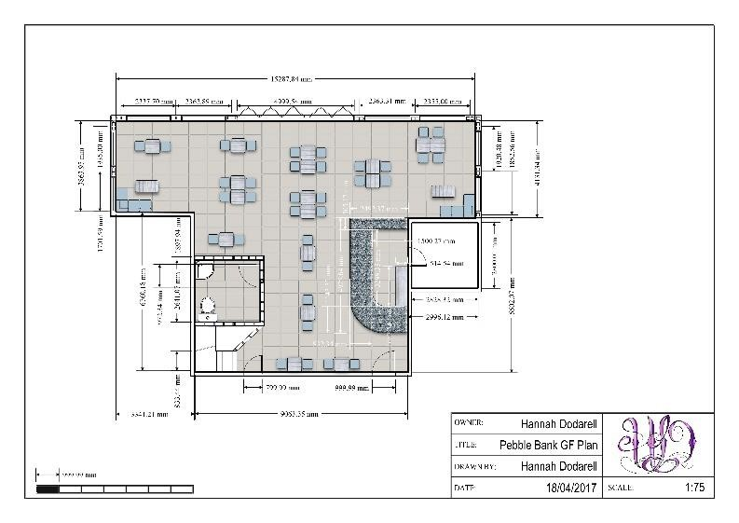
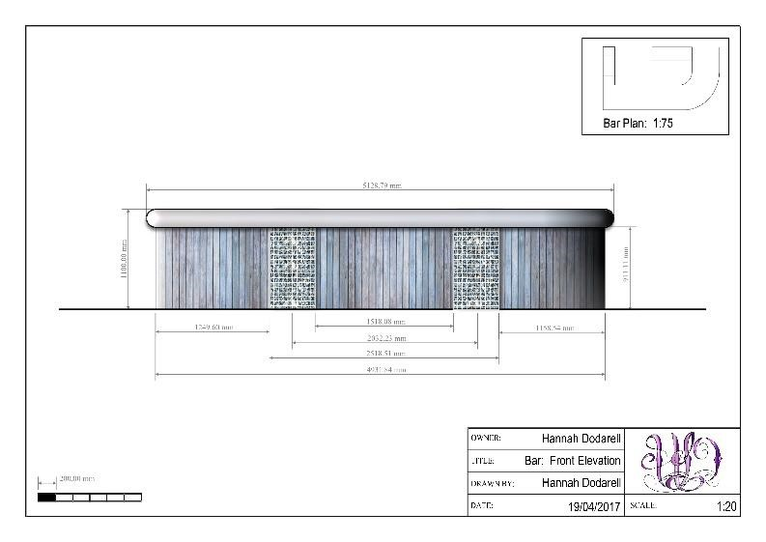
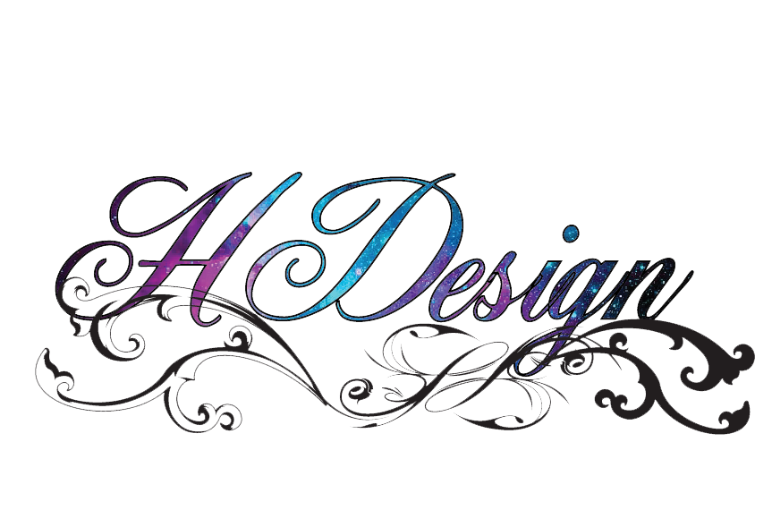

HOBBIES

Drawing & Designing

Reading; Crime
novels, non
-
fiction

Technology

Yacht Design

WORK EXAMPLES

